**PROJECT REPORT**

On

*“*Adamas University Data Repository System”

*Submitted in partial fulfilment of the requirements for the award of*

## Bachelor of Technology (B.Tech)

In the department of

## Computer Science & Engineering



*Submitted by*:

## Riddhi Acharya Srabon Kumar Ghosh (UG/02/BTCSE/2019/067) (UG/02/BTCSE/2019/084)

**Ravi Sharma Amitrajit Chattopadhyay (UG/02/BTCSE/2019/067) (UG/02/BTCSE/2019/016)**

*Under the Guidance of*

## Dr. Sajal Saha (Head Of Department)

**School of Engineering & Technology**

**ADAMAS University, Kolkata, West Bengal**

**Aug 2022 – Sept 2022**

**CERTIFICATE**

This is to certify that the Internship report entitled **“Adamas University Data Repository System”**, submitted to the School of Engineering & Technology (SOET), **ADAMAS UNIVERSITY, KOLKATA** in partial fulfilment for the completion of **Adamas University Data Repository System** of the degree of Bachelor of Technology in the department of **Computer Science & Engineering**, is a record of bonafide work carried out by **Srabon Kumar Ghosh (UG/02/BTCSE/2019/084) , Riddhi Acharya (UG/02/BTCSE/2019/067) , Ravi Sharma (UG/02/BTCSE/2019/064) ,**

**Amitrajit Chattopadhyay (UG/02/BTCSE/2019/016)** under our guidance.

### All help received by us from various sources have been duly acknowledged.

No part of this report has been submitted elsewhere for award of any other degree.

**Dr. Sajal Saha (Head Of Department)**

**Dr. Pranav Kumar (Internship Coordinator)**

**HOD CSE**

# ACKNOWLEDGEMENT

The satisfaction and euphoria that accompany the successful completion of any task would be incomplete without the mentioning of the people whose constant guidance and encouragement made it possible. We take pleasure in presenting before you, our Internship, which is the result of a studied blend of both research and knowledge.

We express our earnest gratitude to our **Dr. Sajal Saha (Head Of Department)**, **Department of Computer Science and Engineering**, for their constant support, encouragement and guidance. We are grateful for their cooperation and valuable suggestions.

Finally, we express our gratitude to all other members who are involved either directly or indirectly for the completion of this Internship.

# DECLARATION

We, the undersigned, declare that the Internship entitled **‘Adamas University Data Repository System’**, being submitted in partial fulfillment for the award of internship certificate in **Bachelor of Technology** Degree in **Computer Science & Engineering**, affiliated to **ADAMAS University**, is the work carried out by us.

## Srabon Kumar Ghosh Riddhi Acharya

**(UG/02/BTCSE/2019/084) (UG/02/BTCSE/2019/067)**

## Ravi Sharma Amitrajit Chattopadhyay

**(UG/02/BTCSE/2019/064) (UG/02/BTCSE/2019/016)**

# ABSTRACT

This project is based on designing a web-based application which provides a very simple

and impressive interface for maintenance of different School of Adamas University for their faculty Project, Research Paper, Journal and other publication. The aim is to make the interface in such a way that it will be very efficient to use and apply activities such as storing university related works and documents of any type. Since our job is based on Database , hence we have the ambition of making it user friendly as one can access anything that is stored in a discipline according to the date modified . The project has a nice and great front-end interface which makes it really easy to understand the method to store the documents like their project ,paper etc. .

In this system the user has to login or sign in to their account as an individual. All the faculty member, students and anyone associated with Adamas University can have their own personal account in this Data Repository System so that no one will have any confusion about their documents being stored. This system is created for easy accessibility and well-maintained storage of all the publications made by our faculty . The publications of the faculties are sorted in school wise.

# TABLE OF CONTENTS

|  |  |  |
| --- | --- | --- |
| **CHAPTER** | **TITLE** | **PAGE** |
|  | **TITLE PAGE** | 1 |
|  | **CERTIFICATE** | 2 |
|  | **ACKNOWLEDGEMENT** | 3 |
|  | **DECLARATION** | 4 |
|  | **ABSTRACT** | 5 |
|  | **TABLE OF CONTENTS** | 6 |
|  | **LIST OF FIGURES** | 7 |
| 1 | **INTRODUCTION** |  |
|  | 1.1 Background | 8 |
|  | 1.2 Problem Statement | 8 |
|  | 1.3 Objective | 8 |
|  | 1.4 Purpose of the Project | 9 |
| 2 | **TECHNOLOGY** |  |
|  | 2.1 Introduction | 10 |
| 3 | **METHODOLOGY** | 11 |
|  | 3.1 MongoDB | 12 |
|  | 3.2 Express JS | 12 |
|  | 3.3 React | 12 |

|  |  |  |
| --- | --- | --- |
|  | 3.4 Node JS | 12 |
| 4 | **OUTPUT** |  |
|  | 4.1 Home Page/ Dashboard | 13 |
|  | 4.2 Sign in Page | 13 |
|  | 4.3 Publication | 14 |
|  | 4.4 Editing or Updating | 14 |
|  | 4.5 Adding a new Publication | 15 |
| 5 | **CONCLUSION** | 16 |
| 6 | **FUTURE WORK** | 17 |
| 7 | **REFERENCE** | 18 |

**LIST OF FIGURES**

|  |  |  |
| --- | --- | --- |
| FIGURE | TITLE | PAGE |
| Figure 3.1 | Structure of MERN stack | 11 |
| Figure 4.1 | Home Page/ Dashboard | 13 |
| Figure 4.2 | Sign in Page | 13 |
| Figure 4.3 | Publication | 14 |
| Figure 4.4 | Editing or Updating | 14 |
| Figure 4.5 | Adding a new Publication | 15 |
| Figure 4.6 | Adding a new Publication | 15 |

# CHAPTER 1 INTRODUCTION

## Background

This project is developed for Adamas University. Faculty Members will have their own separate login and sign-up pages . They can edit , upload, delete their own publications. Our job is to make a web application which will be limited to our own institution only due to which server latency or disturbances will be avoided.

## Problem Statement

We acknowledged that there are plenty of problems related to storing of data and documents online such as uploading projects, papers which are not easily accessible by other faculty members as well as students. There is no free service or system available for publishing paper and maintaining it . There is no download option available also.

We actively require a web application or an interface to clear out these

issues so it will be beneficial for our university.

## Objective

## The main objective of our project is to provide a web-based application which provides

## a very simple and impressive interface for maintenance of the data of all the faculties

## of different Schools of Adamas University for their Projects Research Papers, Journals

## and other publications.

## And also, it will help our faculties to promote and maintain their publications.

## Also, students could easily get access to these publications and acquire knowledge of their

## own interests.

## Purpose of the Internship

The Purpose of our project is to make a simple and efficient interface through which the users can store their personal files such as projects, research paper , documents etc. The main aim is for all the users or the faculty members related or associated to Adamas University to have access to this Data Repository System so that they can keep their essential documents safely in this portal.

This web application will be very simple and impressive as different users will have their personal accounts through which they will enter after logging into their account. After entering into the account, the dashboard will show the options to select the locations about where the different documents are to be placed in an appropriate place so that the work will be in a disciplined manner. The project is based on Database as all the documents being stored in the Data Repository System will be uploaded in the database. Hence, the local device or the user’s personal account storage will not be affected by storing it.

The users can add a document, read it or maybe delete it. Even it has the option to update the credentials and information previously being provided by the user.

# CHAPTER 2 TECHNOLOGY USE

For our Data Repository Project, we have used :

* **SOFTWARE USED :**
  + Windows Operating System
  + Visual Studio
  + Web Browser

## FRONT END :

* REACT JS
* HTML
* CSS
* JAVASCRIPT
* **BACKEND:**
* MONGODB
* **MIDDLEWARE:**
  + NODE JS
  + EXPRESS JS

# CHAPTER 3 METHODOLOGY

We have used the MERN stack developing method. Using React, we created the frontend with all the Ui’s and templates, Express as the framework of Node.js helped us creating the backend and finally and probably the main ambition of our project was the Database which we have undergone using MongoDB.

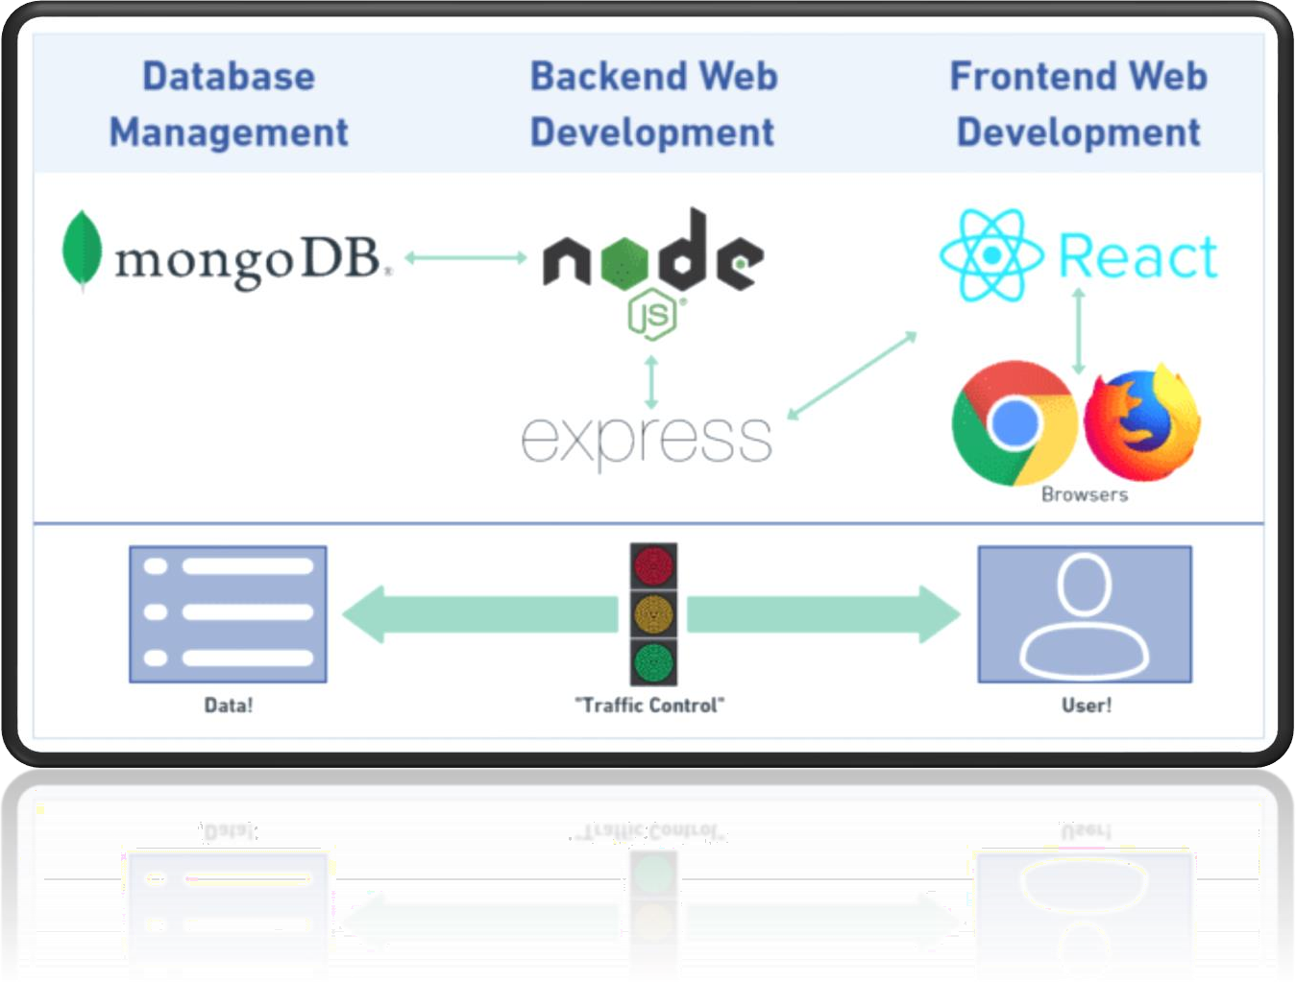

Fig 3.1: Structure of MERN stack

### MongoDB :

The use of Database has been taken by the help of cloud-based database

called MongoDB. It is also a time-saving and simple procedure to use it and to get updates about the data being stored in the database.1

### Express :

As we know, Express is a framework of Node.js . Using it, we have

performed the Backend of our project.2

### React :

It has been a great help using React as it has enabled us to perform the

project in a really efficient way. It has made our JavaScript code easier , handles dependencies and is really helpful in creating the templates. The entire frontend is design with react.3–7

### Node.js :

Node js is use for backend server. As mentioned earlier, the backend part is

being constructed using the framework of Node.js.8,9

# CHAPTER 4 OUTPUT

**Homepage/ Dashboard:** After login user can see their name in the home page.

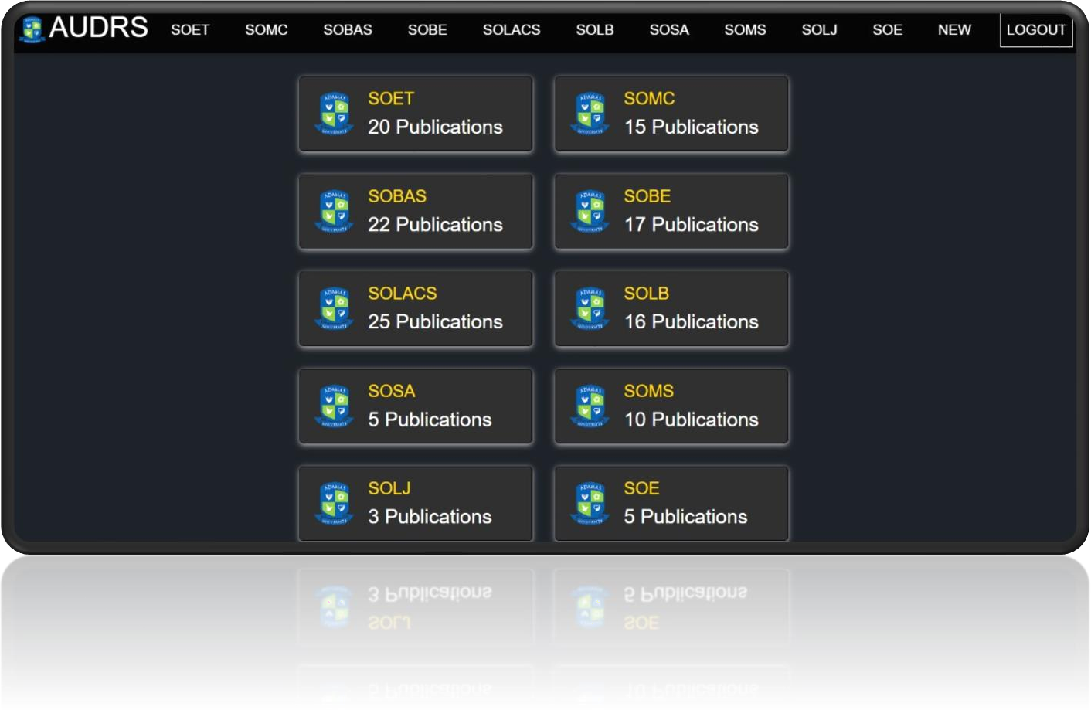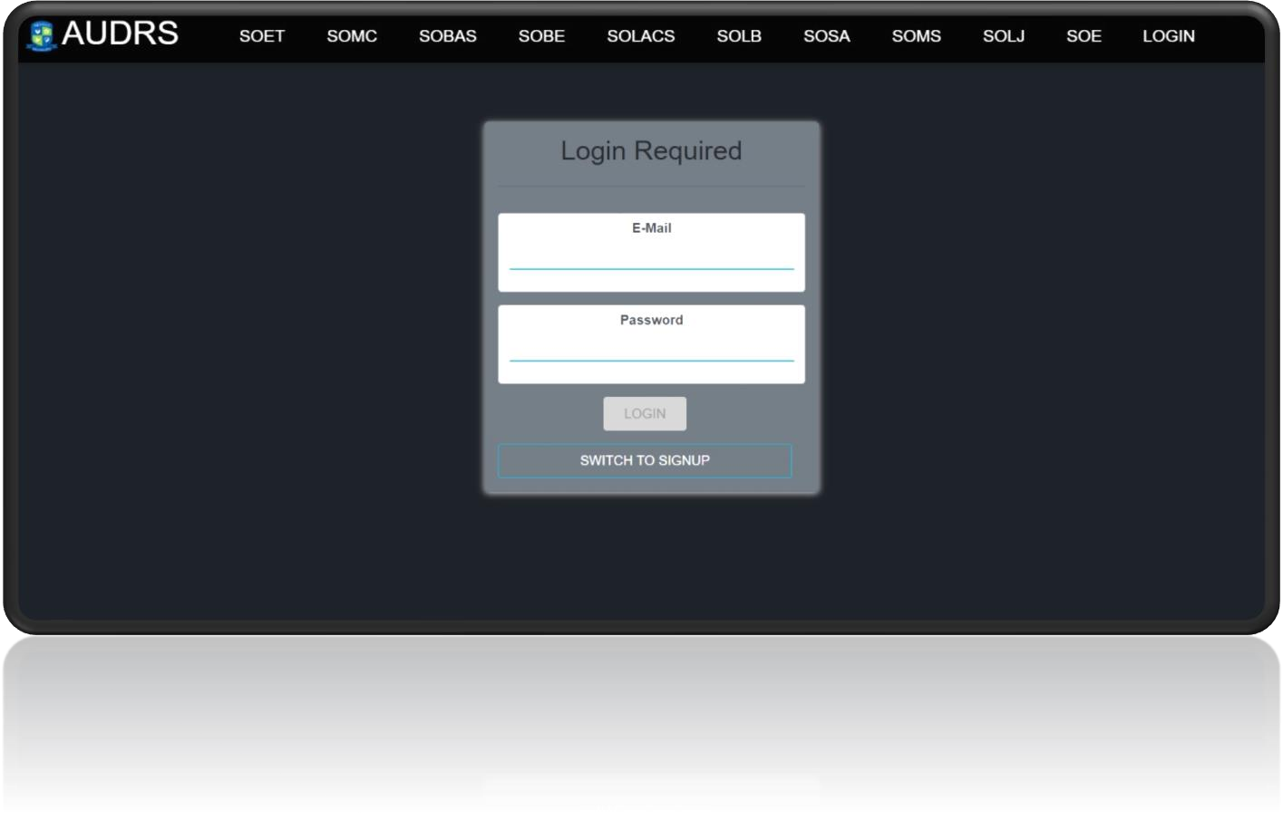

Fig 4.1: Homepage

**Sign in page:** In the sign up page users need to register their selves with their email and password.

Fig 4.2: Sign-in page

13

**Publication:** This page will show all the publications accordingly school wise.

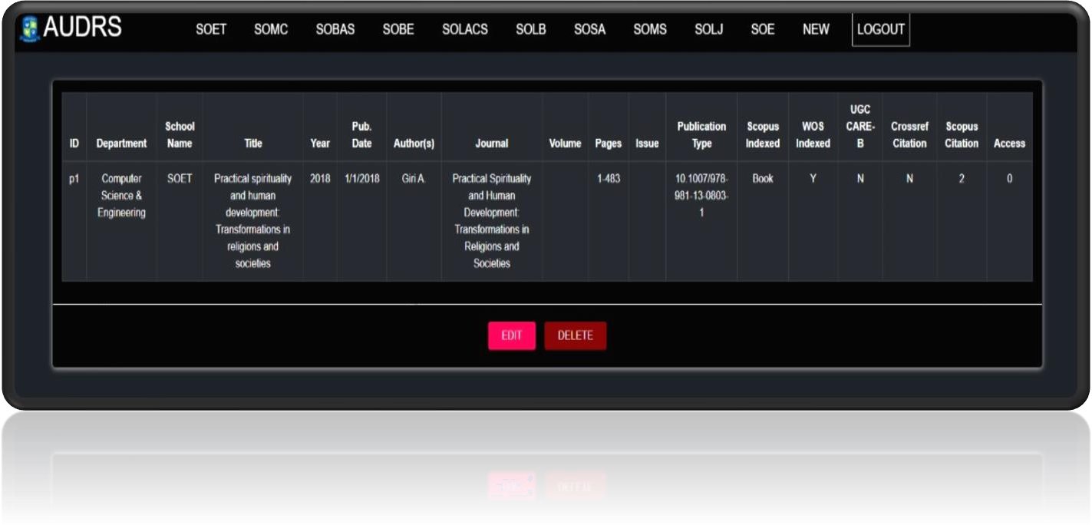

Fig 4.3: Publication page

**Editing or Updating:** This page show updating publications.

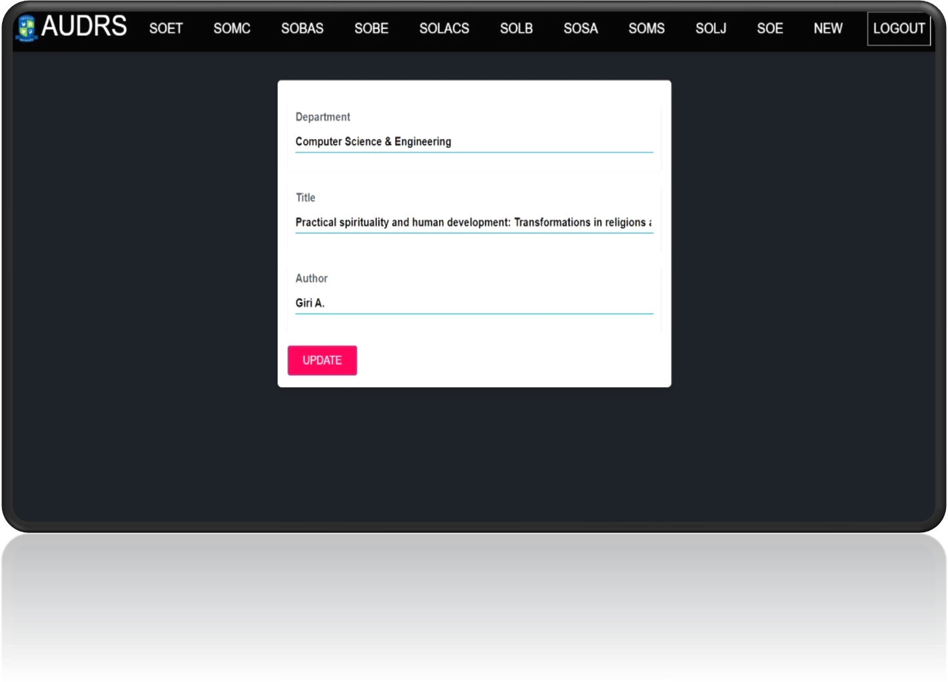

Fig 4.4: Update page

14

**Adding a Publication:** This page show how to add a new publication.

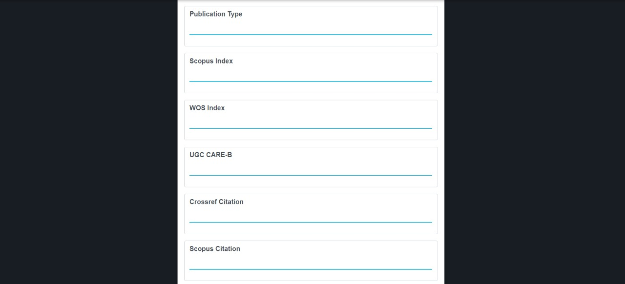

Fig 4.6: New publications page

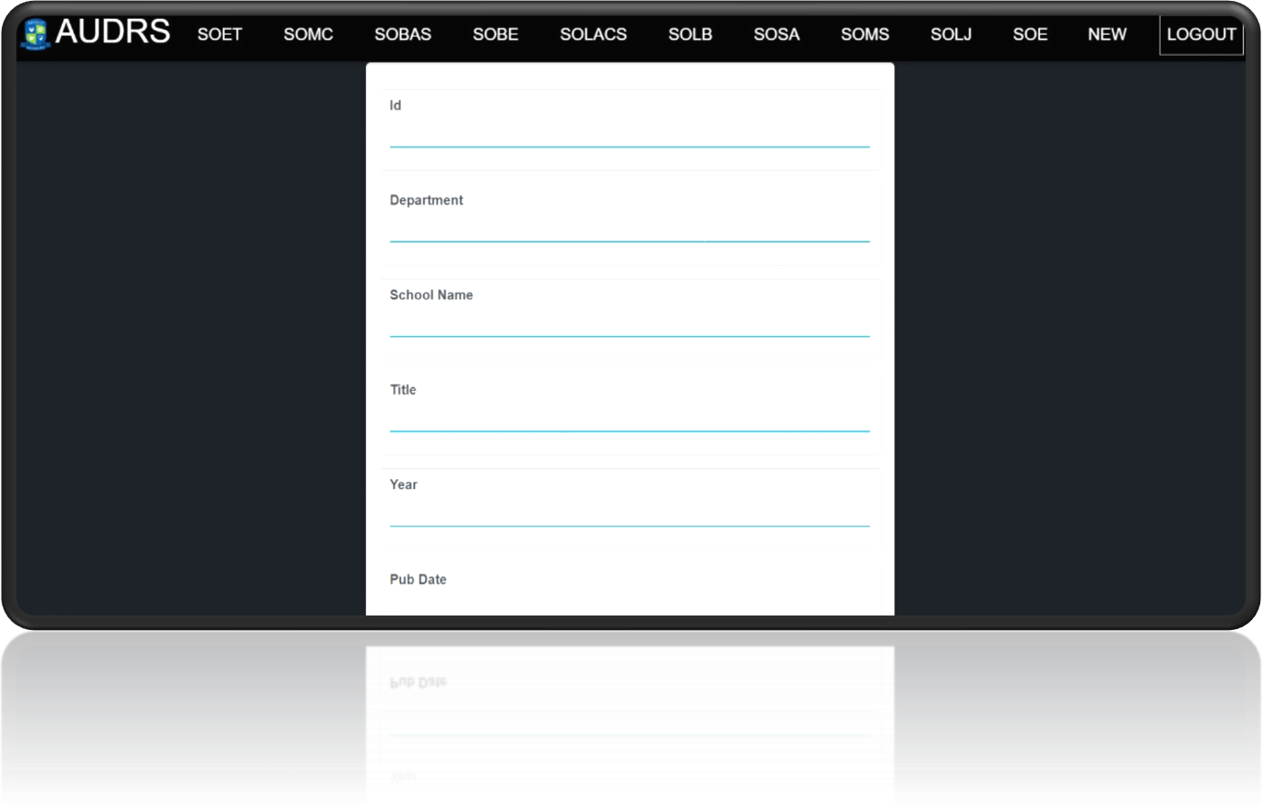

Fig 4.5: New publications page

**CONCLUSION**

Coming to the Conclusion , our project is based on Data-storing related problems as to fulfill our targets, we had to create an interface which is basically being connected to the Database. Our Faculty members will have the opportunity to store their personal journal and publications which will limited to our university.

The Faculty members will have their personal accounts through which they will have the advantage to showcase their publications where everyone in our university can read and download their work.

**FUTURE WORK**

For Future use, we have a concept which will be added after it is being tested successfully by our Faculty members.

### Inclusion of Students to access :

Students of Adamas University can also take the advantage of storing their projects, papers and necessary documents as they can also create their own account where they will edit and store documents.

### Open for all :

All the publications will be available for everyone to read and download.

**Reference**

1. MongoDB Atlas — MongoDB Atlas [Internet]. [cited 2022 Jun 26]. Available from: <https://www.mongodb.com/docs/atlas/>
2. Installing Express [Internet]. [cited 2022 Jun 26]. Available from: <https://expressjs.com/en/starter/installing.html>
3. React-Bootstrap · React-Bootstrap Documentation [Internet]. [cited 2022 Jun 25]. Available from: <https://react-bootstrap.github.io/getting-started/introduction/>
4. React Router [Internet]. [cited 2022 Jun 25]. Available from: <https://www.w3schools.com/REACT/react_router.asp>
5. React useContext Hook [Internet]. [cited 2022 Jun 25]. Available from: <https://www.w3schools.com/REACT/react_usecontext.asp>
6. React Components [Internet]. [cited 2022 Jun 25]. Available from: <https://www.w3schools.com/REACT/react_components.asp>
7. React, NodeJS, Express & MongoDB - The MERN Fullstack Guide | Udemy [Internet]. [cited 2022 Jun 24]. Available from: <https://www.udemy.com/course/react-nodejs-express-mongodb-the-mern-fullstack-guide/>
8. Node.js File System Module [Internet]. [cited 2022 Jun 26]. Available from: <https://www.w3schools.com/nodejs/nodejs_filesystem.asp>
9. Node.js MongoDB Create Database [Internet]. [cited 2022 Jun 26]. Available from: <https://www.w3schools.com/nodejs/nodejs_mongodb_create_db.asp>